# Assumptions/Constraints

For this program to work properly, certain assumptions must be true and certain constraints must be met.

1. No two messages can be sent at the exact same time to the exact same contact. This assumption is reasonable because the sent timestamps for texts are accurate to the second. I do not believe it is possible to send two separate text messages to the exact same contact at exactly the same time. (Group texts, however, are sent out to different contacts at exactly the same time.)

# Database Design

The major issues I faced when trying to distinguish one contact from another were the following:

1. You may have more than one contact with exactly the same name.
2. A phone number can be shared among contacts.

The key to overcoming these issues is that **the phone number a text message is sent from/to will never change. The timestamp and message text will never change**. The name of the contact that a message is sent from/to could change. So, in the event that I had received a text from “John” and his number is 234-456-7890, and then later I change his name to “Juan” and receive another text from him, the below entry would appear in the contacts table:

|  |  |
| --- | --- |
| **Person_name** | **Phone_number** |
| Juan | 234-456-7890 |

This is because changing a contact name will work retroactively on old texts in the XML file. When the XML file is created, it will update contact names accordingly.

Now suppose I had received a text from “Susan” and her phone number is 111-000-4444. I then change her phone number to 333-555-6767 and receive another text from her. I will have the below entries in the contacts table:

|  |  |
| --- | --- |
| **Person_name** | **Phone_number** |
| Susan | 111-000-4444 |
| Susan | 333-555-6767 |

This is because the phone number from which a text is sent can never change. While a contact’s name can be changed (even the name assigned to an old text), the phone number that a text is sent from cannot.

Now, suppose we have the situation in which both the name and the phone number are changed. We have a text from contact named “Ashley” and her phone number is 098-123-2222. Then, I change her name to “Ashley Smith” and change her phone number to 999-888-7777. We will have the below two entries in the contacts table:

|  |  |
| --- | --- |
| **Person_name** | **phone_number** |
| Ashley Smith | 098-123-2222 |
| Ashley Smith | 999-888-7777 |

As is apparent by the above situation, certain assumptions will have to be made regarding how the user organizes his/her contacts:

1. When changing the name of a contact, the user does not create a new contact. So, in the John example above, the contact would update the “John” contact to “Juan” instead of having two contacts, one named “John”, and another named “Juan”.
2. If a contact’s phone number is changed, the old phone number is not deleted. Instead, it is left associated with the contact. This way, the old phone number as well as the new phone number will still be associated with the person’s name, as in the Susan example above. (This constraint need not apply to a phone number for which you have never texted or called. In that case, there would not be any records to change.)

How would we allow two contacts to have the same phone number? This is not a problem, until one of their names is changed. If both received or sent a text or phone call from me before the change, then all the program has to do is check the timestamps and figure out which contact’s name changed. Group text messages will not be affected by this strategy, because recipient contact names are not stored in group text messages (only phone numbers are).

Below is the schema for the tables.

**Contacts**(id, phone_number, person_name)

**Phone_calls**(id, duration, call_timestamp, contact_id)

**Text_messages**(id, msg_text, received_timestamp, sender_id)

**Text_message_recipients**(contact_id, text_message_id)

**Last_backup_date_time**(backup_type, backup_timestamp)

The text_message_recipients table will be the multiway relationship between text_messages and contacts. This table is needed to store the recipient(s) of a text message. (If all texts had only one recipient, then the recipient id/name could simply be stored in the text_messages table. However, you must also account for group texts. That is why I created the text_message_recipients table.)

The contacts table has the following constraint: all (phone_number, person_name) pairs must be unique. This table is in 2NF and 3NF, because a phone_number does not determine the person_name (the name of the contact), and person_name does not determine phone_number. It is possible that two people share the same phone number. Furthermore, it is possible that there are two contacts named “John”. These two columns combined represent a distinct contact.

(The columns person_name, backup_timestamp, backup_type, msg_text, and received_timestamp were so named to avoid using a SQL keyword.)

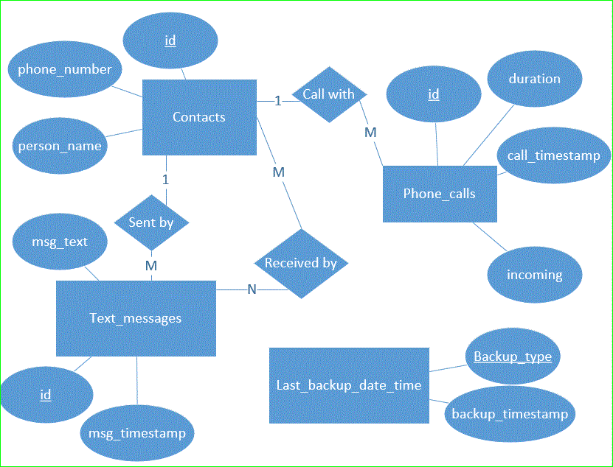

Figure Database Diagram

# Data Dictionary

**backup_timestamp (timestamp)** – the time that the backup occurred.

**backup_type (varchar)** – the type of backup performed at the time specified by the backup_timestamp (acceptable values: “calls” or “texts”).

**call_timestamp (timestamp)** – the date and time of a phone call. This is when the call first came through to my cell phone (if it was an incoming call) or when I first dialed the call (if it was an outgoing call).

**contact_id (integer)** – foreign key pointing to the id of the contact that the phone call was made with.

**duration (integer)** – the duration, in seconds, of a phone call. For example: a duration of 131 would mean a phone call that lasted 2 minutes, 11 seconds.

**id (integer)** – the id of a table is an integer that auto increments. It is the primary key. The id of the contacts table, for example, will be unique and will distinguish each contact.

**msg_text (text)** – the text contained in a text message.

**person_name (string)** – this is the name of a contact. For example: “Phyllis Milton” could be a person_name. The person_name, in combination with the phone_number, is a unique pair.

**phone_number (bigint)** – the phone number is an integer. Every contact has at least one phone_number. A phone_number can be shared between two contacts. The phone_number, in combination with the person_name, is a unique pair.

**received_timestamp (timestamp)** – the date and time a text message was sent (for outgoing texts) or received (for incoming texts).

**sender_id (integer)** – foreign key pointing to the id of a contact that sent the text message. If I sent the text message, then this would be my id; if someone sent the text to me, then this would be their id.

**text_message_id (integer)** – the id of a text message. In the text_message_recipients table, this identifies the text message that a recipient received.